NAME : M.J.N.V. SAI

CLASS : IT – B

ROLL NO : 208W1A12A0

**R LAB – 01**

**TASK – 1 :**

Performing basic mathematical operations and Different Datatypes in R studio..

**PROGRAM :**

1+1

1+2+3+4+5

2*4*5

12*5

4/2

2/4

4*6+5

(4*6)+5

4*(6+5)

a=2

a

b<-10

b

30->c

c

e<-f<-20

e

f

assign("z",50)

z

rm(z)

theVariable <- 17

theVariable

THEVARIABLE

class(a)

is.numeric(b)

i <- 9L

i

is.numeric(i)

is.integer(i)

class(4L)

class(2.8)

s = 4L*2.8

class(s)

class(5L)

s1 = 5L/2L

class(s1)

x1 <- "data set"

x1

nchar(x1)

nchar("welcome")

nchar(5)

nchar(1234)

date1 <- as.Date("2022-03-31")

date1

class(date1)

as.numeric(date1)

date2 <- as.POSIXct("2022-03-31 17:42")

class(date2)

date2

as.numeric(date2)

class(as.numeric(date1))

TRUE*5

FALSE*10

k <- TRUE

k

class(k)

is.logical(k)

T

class(T)

T = 10

T

class(T)

99 == 91

5!=8

9 < 10

9 <= 9

# what is a variable

"data" == "stats"

"data" < "stats"

"data" == "hell"

plot(a,b)

**Output :**

> 1+1

[1] 2

> 1+2+3+4+5

[1] 15

> 2*4*5

[1] 40

> 12*5

[1] 60

> 4/2

[1] 2

> 2/4

[1] 0.5

> 4*6+5

[1] 29

> (4*6)+5

[1] 29

> 4*(6+5)

[1] 44

> a=2

> a

[1] 2

> b<-10

> b

[1] 10

> 30->c

> c

[1] 30

> e<-f<-20

> e

[1] 20

> f

[1] 20

> assign("z",50)

> z

[1] 50

> rm(z)

> theVariable <- 17

> theVariable

[1] 17

> THEVARIABLE

Error: object 'THEVARIABLE' not found

> class(a)

[1] "numeric"

> is.numeric(b)

[1] TRUE

> i <- 9L

> i

[1] 9

> is.numeric(i)

[1] TRUE

> is.integer(i)

[1] TRUE

> class(4L)

[1] "integer"

> class(2.8)

[1] "numeric"

> s = 4L*2.8

> class(s)

[1] "numeric"

> class(5L)

[1] "integer"

> s1 = 5L/2L

> class(s1)

[1] "numeric"

> x1 <- "data set"

> x1

[1] "data set"

> nchar(x1)

[1] 8

> nchar("welcome")

[1] 7

> nchar(5)

[1] 1

> nchar(1234)

[1] 4

> date1 <- as.Date("2022-03-31")

> date1

[1] "2022-03-31"

> class(date1)

[1] "Date"

> as.numeric(date1)

[1] 19082

> date2 <- as.POSIXct("2022-03-31 17:42")

> class(date2)

[1] "POSIXct" "POSIXt"

> date2

[1] "2022-03-31 17:42:00 IST"

> as.numeric(date2)

[1] 1648728720

> class(as.numeric(date1))

[1] "numeric"

> TRUE*5

[1] 5

> FALSE*10

[1] 0

> k <- TRUE

> k

[1] TRUE

> class(k)

[1] "logical"

> is.logical(k)

[1] TRUE

> T

[1] TRUE

> class(T)

[1] "logical"

> T = 10

> T

[1] 10

> class(T)

[1] "numeric"

> 99 == 91

[1] FALSE

> 5!=8

[1] TRUE

> 9 < 10

[1] TRUE

> 9 <= 9

[1] TRUE

> # what is a variable

> "data" == "stats"

[1] FALSE

> "data" < "stats"

[1] TRUE

> "data" == "hell"

[1] FALSE

> plot(a,b)

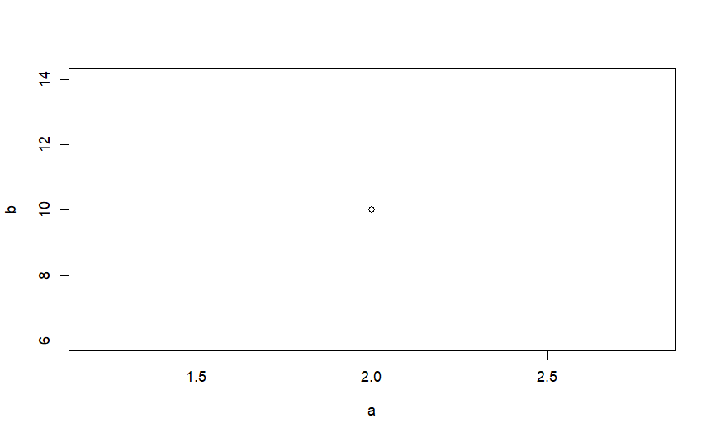

**TASK – 02 :**

Importing Random Excel Dataset From Internet

